Generate Array Diagnostic report from ACU

Today I am writing about HP Array Diagnostic report. Before we speak about this report, you need to understand what is an Array, RAID and Array Configuration Utility (ACU). In the case of hardware RAID, multiple hard disk drives are combined to one logical drive and data is distributed across multiple hard drives. You can have RAID levels like RAID 0, RAID 1, RAID 5 etc. To understand more about Array, RAID and ACU, please read our Guide by clicking this link.
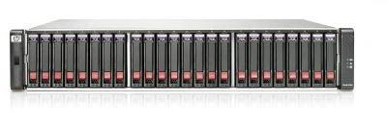I hope you are familiar with Array Configuration Utility. Using Array Configuration Utility, we can generate Array Diagnostics report (ADU). ADU report is used for troubleshooting issues related to Hard drives, Smart Array Controller, Array Accelerator and Cache battery etc.
Please be informed that ADU report will not collect data content of logical/Physical drives. It only captures hardware information hence all of your data information is secured. ADU report could not capture File system types, contents, Software RAID information, Partition types, sizes etc.
ADU report can give consolidated view of any error or warning conditions encountered across the Array/RAID. ADU report also provides extensive information about all the storage devices. Information such as Device status, Firmware version number, RAID Configuration, Physical drive error flags are available in ADU report.
In this article, we will learn how to generate ADU report using Array Configuration Utility (ACU). If you are not sure how to open ACU on your Server, then please read our article “Guide: Configure RAID using HP ACU on your HP Server” before you proceed. ACU can be launched within OS or from HP SmartStart CD. More information is available in above said guide.
In Windows you can launch Array Configuration utility by Clicking Start –> Programs ->HP System Tools –> HP Array Configuration Utility.In Linux, You can launch ACU from System Management Homepage (GUI)
Generate Array Diagnostics report report using ACU:
1. Open HP Array Configuration utility on your Server.
2. Select the HP Smart Array Controller from the list.
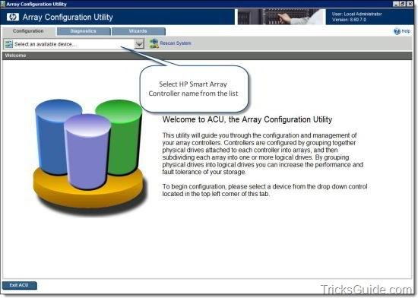
3. Now ACU opens and you will be at the Configuration Window of the ACU.
4. Click the Diagnostics tab at the top
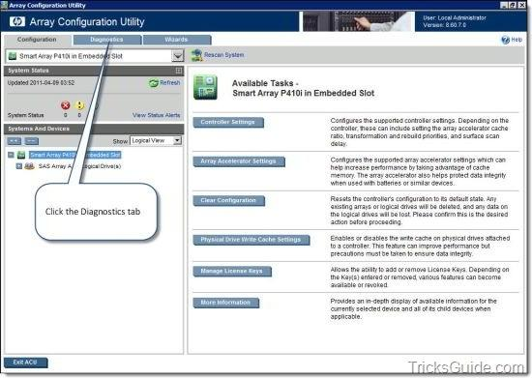
5. The Diagnostics tab will look like the one provided below.
Note: Diagnostics tab displays a list of HP Smart array controllers and options for generating, viewing, and saving array diagnostic reports for those controllers.
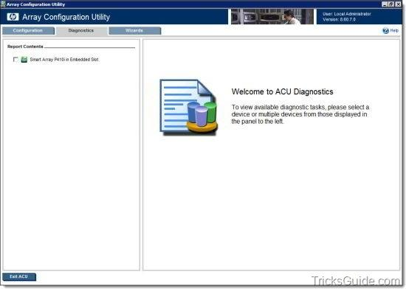
6. Select the Smart Array controller name from the left pane of the window.
7. Click on “Generate Diagnostic Report” button.
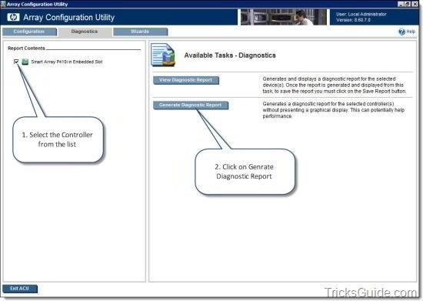
8. ADU report will be generated in a minute.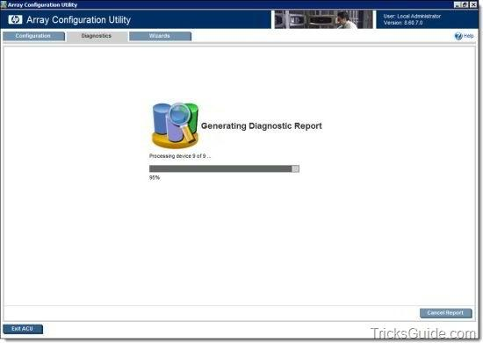
9. Once the report is generated, click on Save Report button.
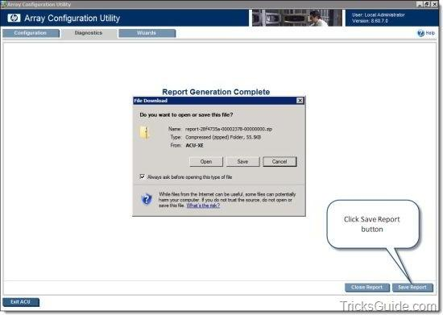
Note: If you were using ACU from SmartStart CD, you can save the ADU report to a formatted diskette or USB drive key. If you are using ACU Within Windows/Linux, then you can save the file to a folder/directory.
10. Once you save the report, click on Close report button.
11. Click Exit ACU button to close ACU.

Whenever you experience Hard drive failure, Smart Array Controller failure, BBWC/FBWC issues or Array battery issues on your HP server, always generate the ADU report and send it for analysis. The report will give enough information about the failure.
- See more at: http://webcache.googleusercontent.com/search?q=cache:bzEoez-gDusJ:www.tricksguide.com/hp-generate-array-diagnostic-report-adu-from-acu.html+&cd=1&hl=ru&ct=clnk&gl=ru#sthash.SOUNuXCk.dpuf

